Question 7
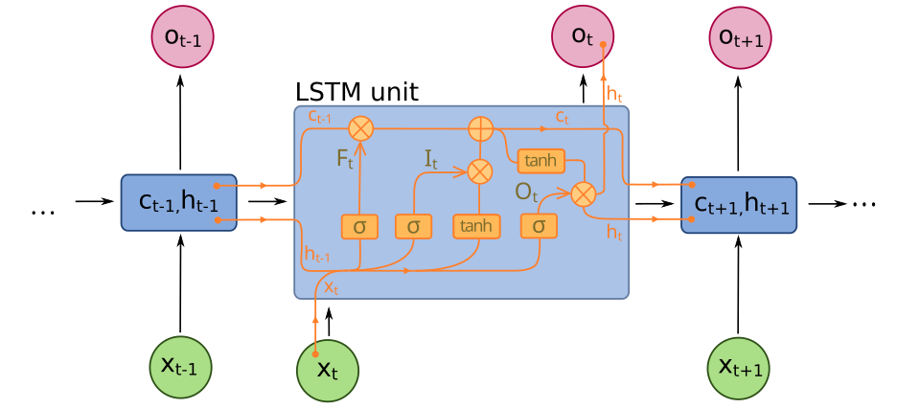

Foreword: I do not have the time, nor tools to circle the above in MS word. So do your best to bare with me.

There are four component gates in an LSTM cell. Each fate us computed from the current input x_{t} and the previous hidden state h_{t-1.} σ is sigmoid. Tanh is hyperbolic tangent, and the crossed o is element wise multiplication.
1: The forget gate (σ node on the left path to C_{t-1})
$$F_{t}=σ(W_{f}x_{t}+ U_{f}h_{t-1}+b_{f})$$
This chooses how much of the previous cell to keep: C_{t-1} * F_{t}. Values near 0 are erased, values near 1 are kept.

2: The input gate I_{t} (σ node on the lower left path)
$$I_{t}= σ(W_{f}x_{t}+ U_{i}h_{t-1}+b_{f})$$
Decides how much new information to write to memory.

3: Candidate (cell write) C_{t} (tanh node feeding the cell)
$$C_{t}=tanh⁡(W_{c}x_{t}+ U_{0}h_{t-1}+ b_{c}$$
Proposes new content to store, combined with the input gate to update memory.

4: The Output gate O_{t} (σ node to the right learning to h_{t})
$$O_{t}= σ(W_{0}x_{t}+ U_{0}h_{t-1}+ b_{0})$$
Controls how much of the squashed cell state becomes the hidden input.

The State Updates as they work together.
$$C_{t}= F_{t}* C_{t-1}+ I_{t}*C_{t} , h_{t}=O_{t}*tanh⁡(C_{t})$$

So, the forget gate keeps/erases past memory, the input gate + candidate write new memory, and the output gate reads the memory to produce h_{t}.

